Introduction to Research

Research: Objectives and Characteristics
The statement “Research is the systematic approach to obtaining and confirming new and reliable knowledge” is justified because research is a planned and scientific process used to discover new facts, verify existing knowledge, and establish reliable conclusions.
- Systematic and Orderly: Follows a planned, logical, and sequential process of problem identification, literature review, data collection, analysis, and conclusion.
- Obtaining and Confirming: Discovers new information and tests, verifies, and confirms existing theories and findings using scientific methods.
- New and Reliable Knowledge: Transforms collected information into new understanding based on evidence and proper analysis, making findings reliable and replicable.
Dimension | Routine Information Gathering | Scientific Research
Activity | Collects and compiles existing information. | Critically analyzes and synthesizes information.
Data Handling | Simple data collection with limited analysis. | Rigorous data processing and statistical/qualitative analysis.
Methodology | Often informal or unstructured. | Systematic, controlled, and scientifically designed.
Outcome | Retrieves known facts and describes what is. | Generates new knowledge and explains why/how things occur.
Continuity | Stops when the information need is fulfilled. | Continuous cycle that generates new research questions.
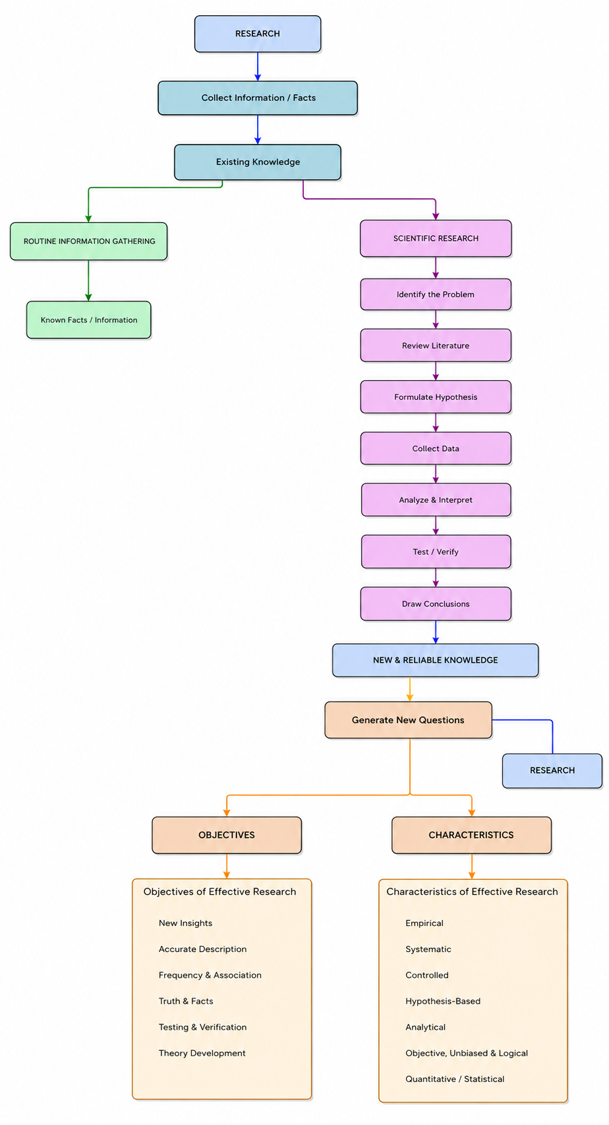Therefore, research is a systematic scientific process for discovering, verifying, and establishing new and reliable knowledge.

Objectives of Effective Research
- New Insights: Gain familiarity and new insights into a phenomenon.
- Accurate Description: Describe individuals, groups, or situations accurately.
- Frequency & Association: Determine frequency or association between variables.
- Truth & Facts: Discover truth, facts, and unexplored knowledge.
- Testing & Verification: Test existing conclusions and resolve contradictions.
- Theory Development: Develop new theories or conceptual frameworks.

Characteristics of Effective Research
- Empirical: Based on observation and experimentation.
- Systematic: Follows an orderly and sequential process.
- Controlled: Controls relevant variables to ensure valid results.
- Hypothesis-Based: Uses testable hypotheses to guide investigation.
- Analytical: Critically analyzes data and findings.
- Objective, Unbiased & Logical: Based on evidence and free from personal bias.
- Quantitative/Statistical: Uses numerical and statistical analysis where applicable.

Conclusion
Thus, research is a systematic, empirical, controlled, analytical, and objective process that helps discover, verify, and establish new and reliable knowledge. Its objectives and characteristics ensure that research findings are scientifically valid and useful for solving problems and developing knowledge.

  - Types of Research
A research paradigm or worldview is a set of basic beliefs and assumptions that guides how a researcher understands reality, collects data, and conducts research.
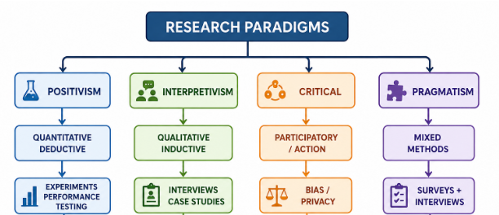
Figure: Research Paradigms

1. Positivism / Postpositivism
- Belief: Objective reality exists and can be studied through observation and measurement.
- Methodology: Quantitative, deductive, hypothesis-based, and controlled.
- IT Example: Experimentally comparing the performance of two algorithms using processing time and accuracy.

2. Social Constructivism / Interpretivism
- Belief: Reality and meaning are socially and historically constructed through human experiences.
- Methodology: Qualitative, inductive, and uses open-ended data collection.
- IT Example: Studying users’ experiences and perceptions of a software system through interviews or case studies.

3. Advocacy / Participatory / Critical Research
- Belief: Research should address power, inequality, social justice, and real-world problems.
- Methodology: Collaborative, participatory, and action-oriented.
- IT Example: Using action research to improve a system with active participation of users or studying algorithmic bias and privacy.

4. Pragmatism
- Belief: Focuses on what works to solve a specific research problem rather than following one philosophy.
- Methodology: Mixed-methods, combining quantitative and qualitative approaches.
- IT Example: Using surveys to measure system satisfaction and interviews to understand the reasons behind the results.

Influence on IT and Computer Systems Research
Paradigm | Methodology | Typical IT Research
Positivism/Postpositivism | Quantitative | Experiments, performance testing
Constructivism/Interpretivism | Qualitative | HCI, usability, user experience
Critical Research | Participatory/Action | Algorithmic bias, privacy, system improvement
Pragmatism | Mixed-methods | System adoption, evaluation

Conclusion: Research paradigms influence the research questions, methodology, data collection, analysis, and interpretation used in IT and computer systems research.

  - The 6 P's of Research

1.3 The 6 P's of Research
Exam Target: Explain the 6 P's of Research • Role in shaping a research project • Is research merely an accidental discovery?

10-Mark Answer Pattern

1

Definition
1 Mark
Research and definition of the 6 P's.

2

Introduction
1 Mark
Explain why research is not merely accidental discovery.

3

Main explanation
4 Marks
Explain all 6 P's with IT examples.

4

Table/Diagram
2 Marks
Draw the 6 P's relationship diagram and summary table.

5

Application
1 Mark
Mention importance in IT research.

6

Conclusion
1 Mark
End with the overall significance of the 6 P's.

1. Definition (1 Mark)
Research: Research is a systematic, scientific, and creative process of obtaining and confirming new and reliable knowledge.
6 P's of Research: A framework proposed by B.J. Oates consisting of:
Purpose, Process, Products, Participants, Paradigm, and Presentation
It provides a complete blueprint for conducting a rigorous and academically valid research project.

2. Introduction (1 Mark)

Is research merely an accidental discovery?
No. Research is not merely an accidental discovery because it is a planned, systematic, controlled, and empirical investigation.
Although serendipitous findings may occur, they become scientific knowledge only after systematic verification, analysis, and validation through the research process.

3. Main points: The 6 P's with IT examples (4 Marks)

6 P’s of Research — Short Notes
The 6 P’s of Research are:
Purpose → Products → Process → Participants → Paradigm → Presentation

1. Purpose — Why?
The reason for doing the research. It identifies the research problem, objectives, aims, research questions, importance, and relevance of the study.
Key question: Why is the research being conducted?

2. Products — What?
The outcomes of research and the contribution it makes to knowledge. Products may include expected or unexpected findings, thesis, dissertation, conference paper, or journal article.
Key question: What knowledge or outcomes has the research produced?

3. Process — How?
The sequence of activities followed in research, including selecting the topic, developing a conceptual framework, choosing a research strategy, collecting and analyzing data, drawing conclusions, and identifying limitations.
Key question: How was the research conducted systematically?

4. Participants — Who?
People directly or indirectly involved in the research, such as interviewees, respondents, researchers, editors, or other stakeholders. They must be treated legally and ethically, with respect and without causing harm.
Key question: Who is involved and what are the ethical/legal issues?

5. Paradigm — Worldview
A pattern, model, or shared way of thinking that guides research. Major philosophical paradigms include:
- Positivism: Observable facts, measurement, objectivity.
- Interpretivism: Subjective meaning and human experiences.
- Critical Research: Challenges social structures and power.
Key question: What philosophical worldview guides the research?

6. Presentation — Communication
The means by which research is disseminated and explained to others, such as through a thesis, dissertation, conference paper, journal article, or product demonstration. It should be clear and professional.
Key question: How is the research communicated to others?

4. Diagram + Summary Table (2 Marks)
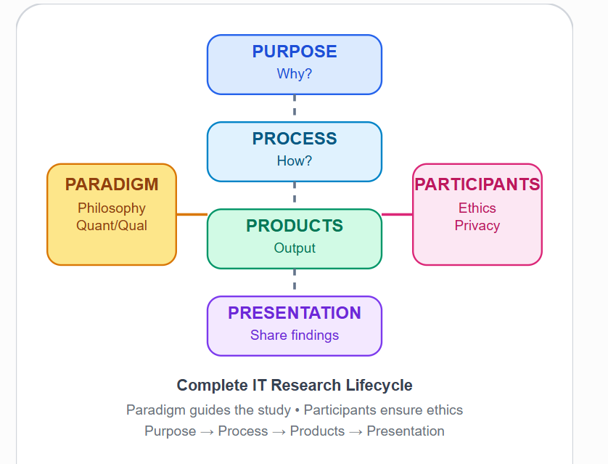
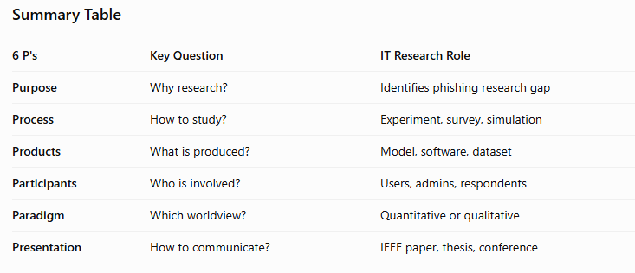

5. Application in IT Research (1 Mark)
- Ensures systematic and rigorous methodology in software and cybersecurity research.
- Protects privacy, informed consent, and research ethics while collecting user data.
- Helps produce reliable software artifacts, algorithms, datasets, and publications.

6. Conclusion (1 Mark)
The 6 P's of Research provide a complete framework for transforming a research problem into a systematic, ethical, valid, and professionally presented contribution to scientific knowledge.

Memory Trick: 6P = 3P + 2P + 1P

Purpose

Process

Products

Paradigm

Participants

Presentation
Mnemonic: PPP + PP + P → Purpose → Process → Products → Paradigm → Participants → Presentation

  - Research Process

Creativity in the Research Process
Research is a creative process. It requires more than just logic.
“Research includes far more than mere logic... It includes insight, genius, groping, pondering, ‘sense’... The logic we can teach; the art we cannot.”
Research works best with:
- Imagination
- Initiative
- Intuition
- Curiosity
Creativity may provide the difference between satisfactory and outstanding research.

  - Research in Computer Science and Engineering
How is research defined and conceptualized within the field of computer engineering? (2025 Spring Preboard

1. Definition — 1 Mark
Research in Computer Engineering is a rigorous, systematic, and creative inquiry conducted to advance computational knowledge, develop innovative technologies, and solve practical and theoretical problems related to computation, software, and hardware.
Key words to remember:
Rigorous + Systematic + Creative → Knowledge + Innovation + Problem Solving

2. Introduction — 1 Mark
Research in Computer Science and Engineering (CSE) is different from research in classical sciences because it often focuses on artificial or human-made artifacts, such as:
- Algorithms
- Databases
- Network protocols
- Software systems
- Hardware architectures
CSE research combines abstract logic and mathematics with empirical execution and system development.

3. Main Points — 4 Marks

A. Dual Nature of CSE Research
Computer Engineering research has two major dimensions:

1. Theoretical Dimension
Focuses on the mathematical and conceptual foundations of computing.
Examples:
- Mathematical proofs
- Computational complexity
- Core algorithms
- Cryptography
- Theoretical limits of computation

2. Practical / Experimental Dimension
Focuses on developing and evaluating actual computing systems.
Activities include:
- Designing
- Building
- Simulating
- Testing
- Optimizing
Example: Developing and testing a phishing website detection algorithm.

B. Major Objectives of CSE Research
Remember: I-O-A-P-K
Objective | Meaning
Innovation | Develop new technologies, algorithms, or systems
Optimization | Improve performance, efficiency, accuracy, or resource use
Automation | Reduce human effort through intelligent/computational systems
Problem Solving | Address practical and theoretical computing problems
Knowledge Advancement | Generate new computational knowledge and understanding

C. Major Research Approaches
Approach | Description | Example
Experimental Research | Manipulates variables and measures their effects | Compare two phishing detection algorithms
Simulation-based Research | Uses computational models in a controlled virtual environment | Simulate network traffic
Theoretical Research | Uses logic, mathematics, assumptions, and conceptual systems | Prove an algorithm's complexity
Multidisciplinary Research | Combines CSE with another field | Bioinformatics

4. Diagram / Conceptual Framework — 2 Marks
A strong diagram can make the answer more complete:
RESEARCH IN CSE
│
┌───────────┴───────────┐
│ │
▼ ▼
THEORETICAL PRACTICAL /
DIMENSION EXPERIMENTAL
│ │
▼ ▼
Mathematics, Design, Build,
Algorithms, Simulate, Test,
Complexity, Optimize
Cryptography │
│ │
└───────────┬───────────┘
▼
NEW KNOWLEDGE
+
INNOVATIVE SOLUTIONS

Research Cycle in CSE
Theory
↕
Modelling & Simulation
↕
Experiment
↕
Analysis & Evaluation
↕
New Knowledge / Innovation
This shows that CSE research is not simply software development; it involves a continuous relationship between theory, modelling, simulation, experimentation, and evaluation.

5. Applications / Examples — 1 Mark
CSE research can be applied to many areas:
Research Area | Example Metrics
Cybersecurity | Accuracy, F1-score, latency, false-positive rate
Databases | Processing time, query throughput, memory usage
Software Engineering | Productivity, bugs, defect rate
Theoretical CS | Big-O complexity, space/time complexity

Example
In phishing website detection, a researcher may develop an algorithm and experimentally evaluate it using:
Detection Accuracy + F1-score + False Positive Rate + Latency

6. Conclusion — 1 Mark
Research in Computer Engineering is a systematic, rigorous, and creative process that combines theoretical reasoning with practical experimentation. It goes beyond simply developing software or hardware by theorizing, designing, modelling, simulating, experimenting, analyzing, and evaluating systems to generate credible knowledge and innovative solutions.

⭐ 10-Mark Answer Structure to Memorize
For the actual exam, remember:
1. DEFINITION
↓
2. INTRODUCTION
↓
3. DUAL NATURE
→ Theoretical
→ Practical/Experimental
↓
4. OBJECTIVES
→ Innovation
→ Optimization
→ Automation
→ Problem Solving
→ Knowledge Advancement
↓
5. APPROACHES
→ Experimental
→ Simulation
→ Theoretical
→ Multidisciplinary
↓
6. DIAGRAM
↓
7. EXAMPLE / APPLICATION
↓
8. CONCLUSION

🧠 One-line Memory Trick
“Research in CSE = Theory + Experiment → Knowledge + Innovation + Problem Solving.”
This structure is particularly useful because even if the examiner changes the wording—for example, asks about the nature, concept, objectives, or research approaches of Computer Engineering research—you can adapt the same notes to answer it.

